**DSA ASSIGNMENT 3**

**Submitted By: Purbasha Roy  
Roll No.: 102015150  
Sub Group: 2NC7**

**Q1. Write a function to perform following operations on the string:  
(Note: You can make single function for all operations/independent function for each  
problem)**

1. **Finding length of a string**

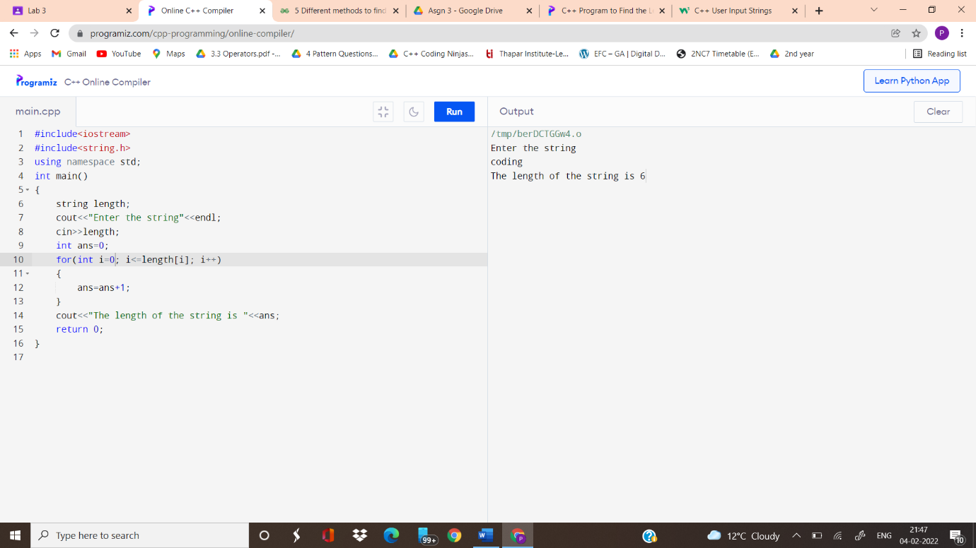

1. **Converting a string in lowercase**

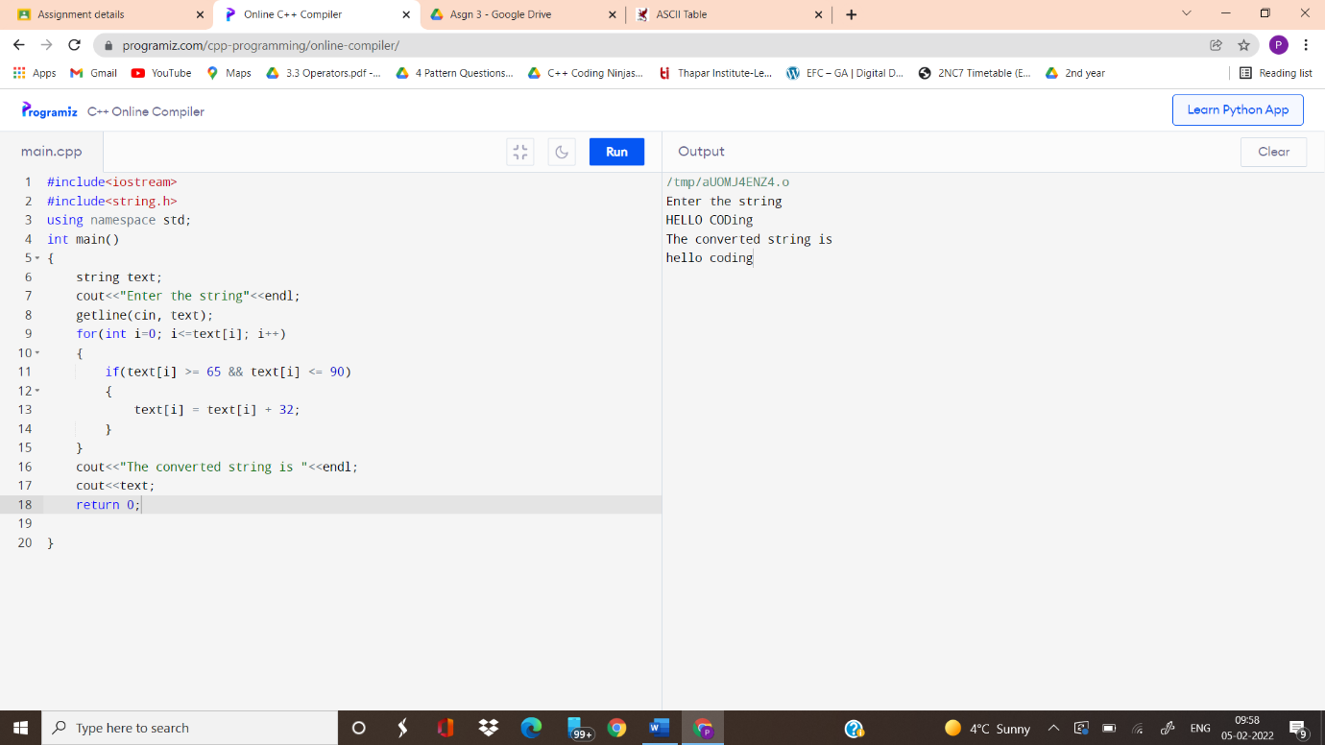

1. **Counting number of words and vowels in a string**

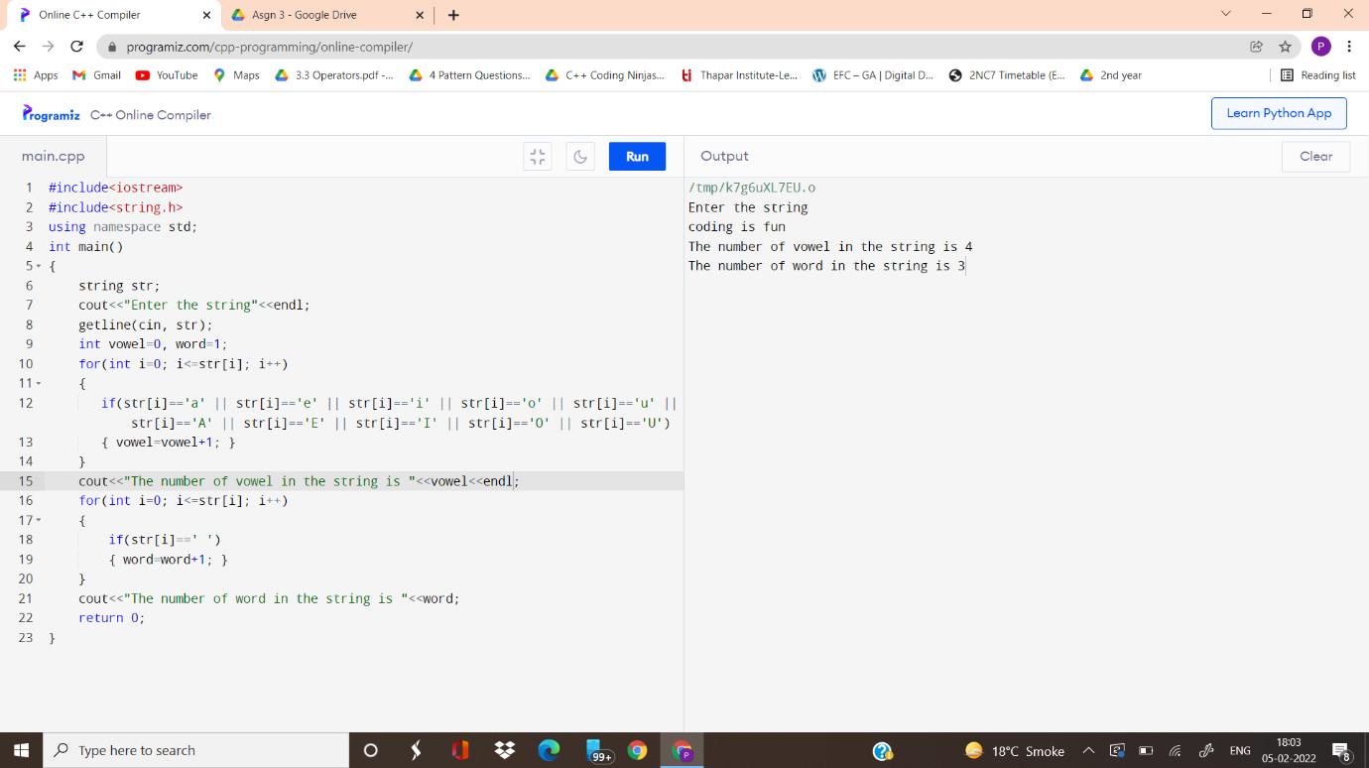

1. **Validating a string (Note: Valid string does contain only alphabets)**

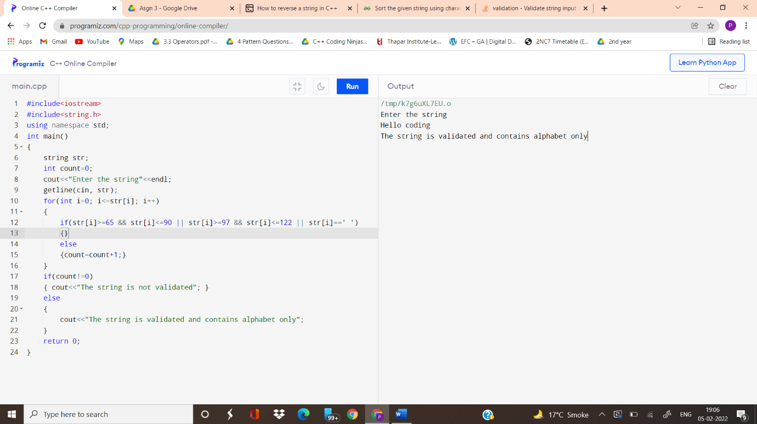

1. **Reversing a string (Eg. Code to edoC)**

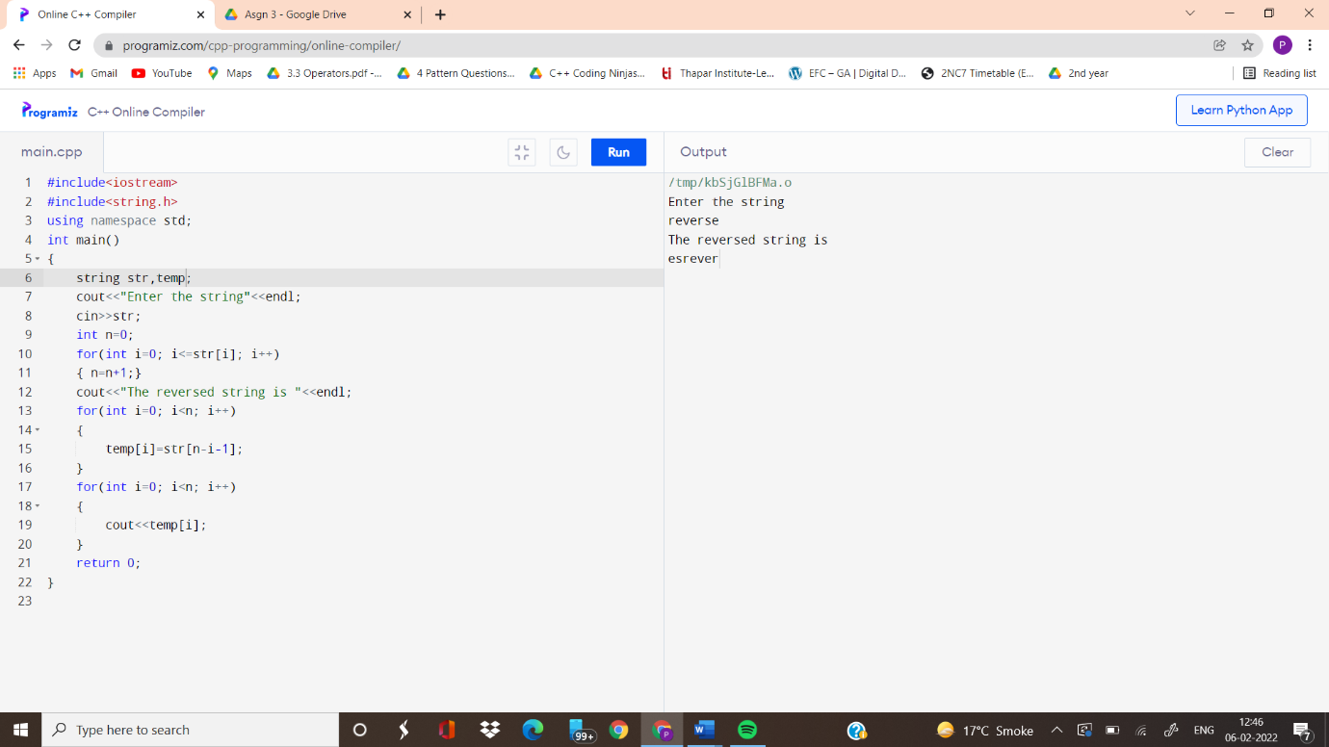

1. **Checking if a string is palindrome.**

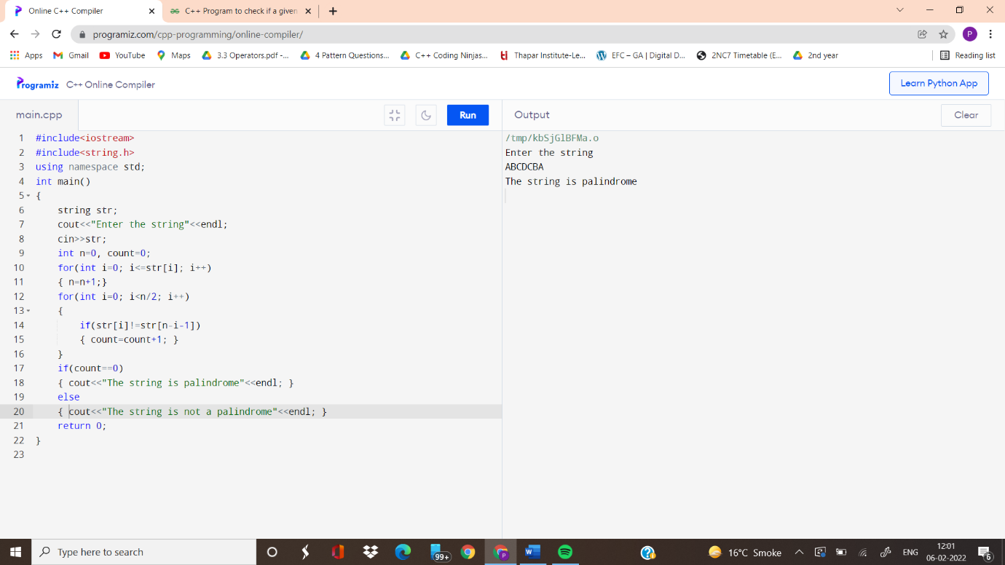

1. **Finding duplicate characters in a string (Note: print the duplicate characters only once, irrespective of the number of times it occurred)**

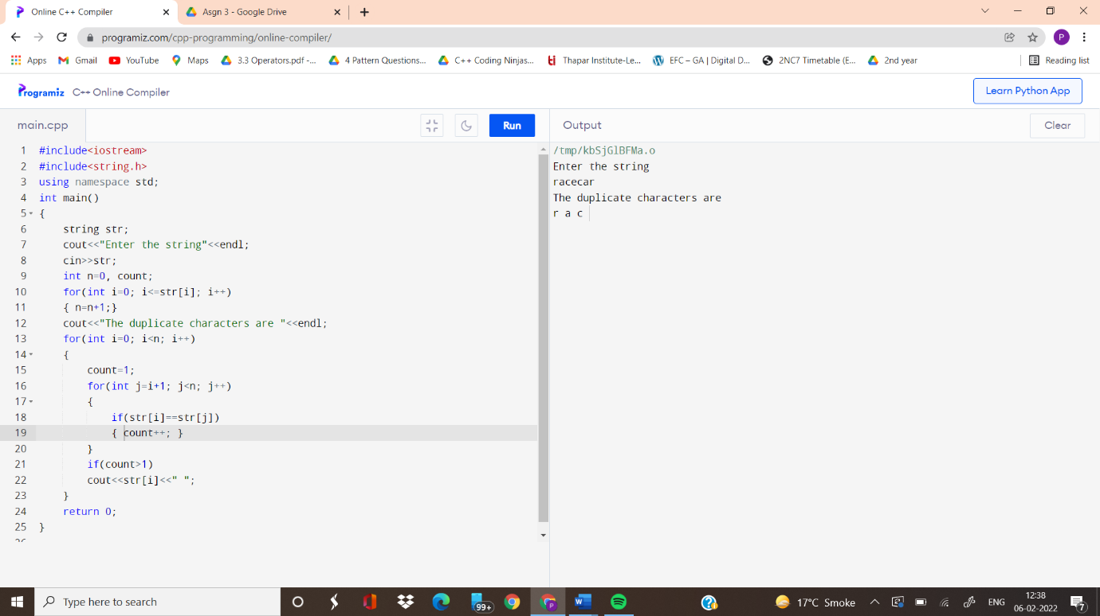

**Q2 Sort the characters of the string entered by user.**

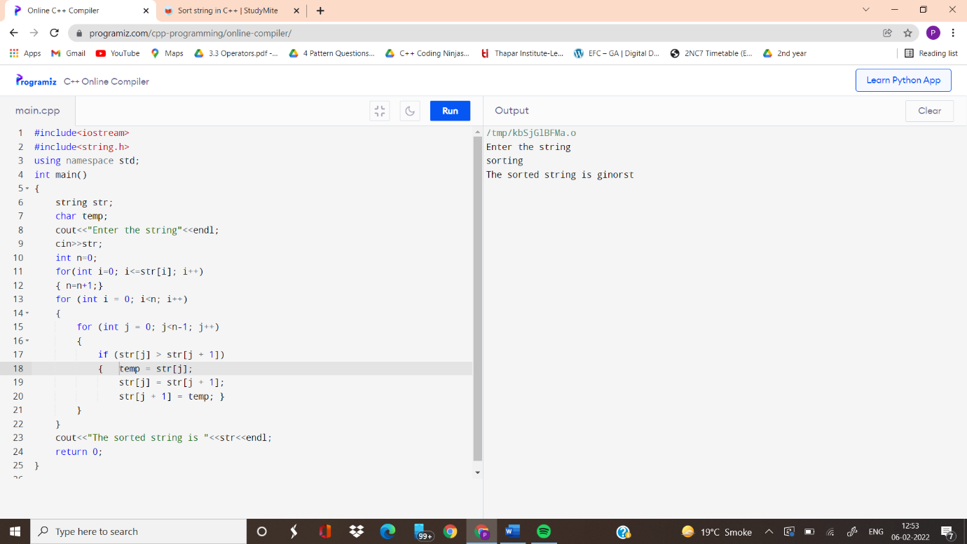

**Q3. Implement combination formula n C r using recursion.**

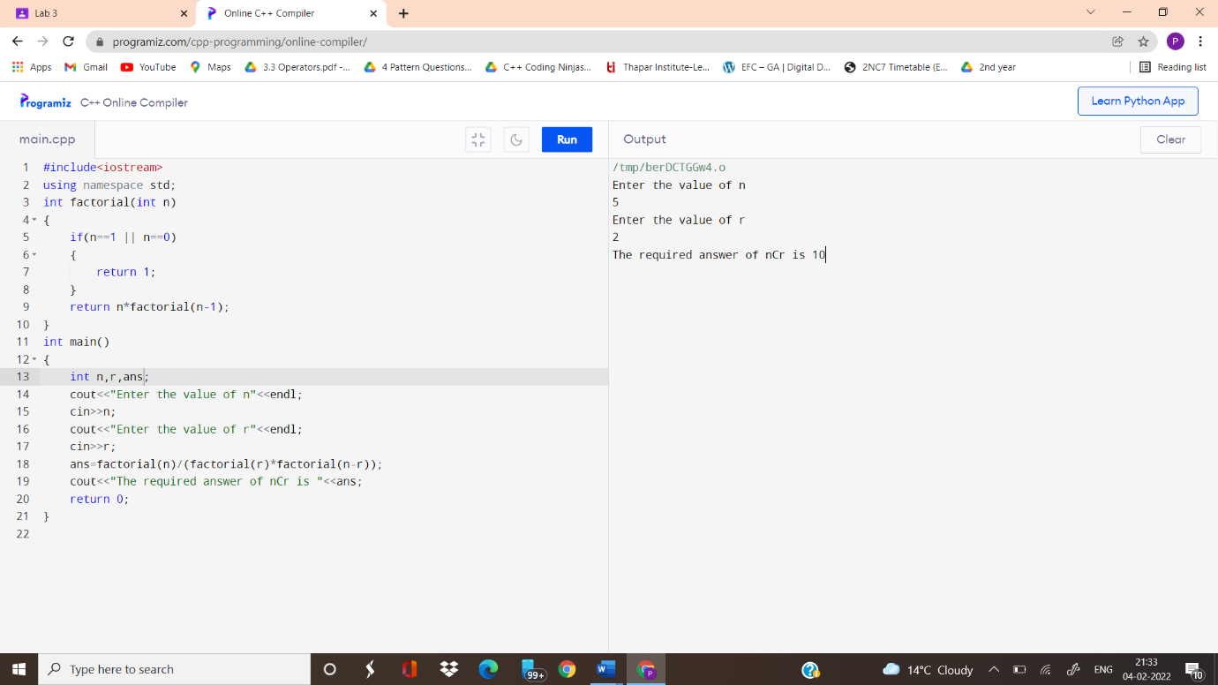

**Q4. Implement the Fibonacci series using recursion**

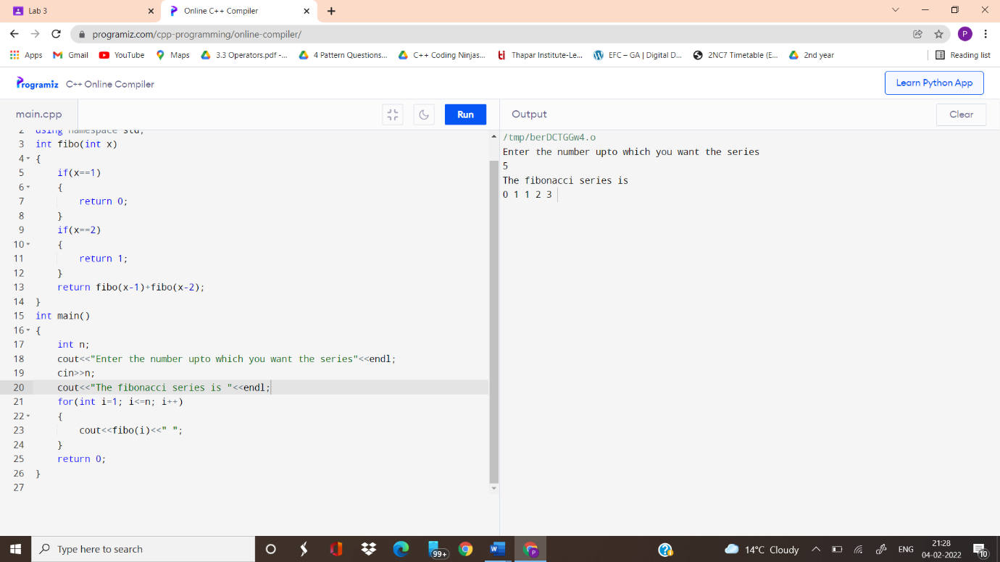

**Q5 Write a program for finding the factorial of a number recursively.**

